**KALA PRE-TRIALS EXAMINATION - 2025**

***Kenya Certificate of Secondary Education***



**121/1**

**MATHEMATICS ALT A Paper 1**

**MARCH 2025 2 ½HOURS**

**Name:** …………………………………………..………… **Admission No** ………..….

**School ……………………….…Class**………. **Signature …………..Date:** …………...

***Instructions to candidates***

1. *Write your* ***name****,* ***admission*** *number and* ***school*** *in the spaces provided above.*
2. *Sign and write the date of the examination in the spaces provided above.*
3. *The paper contains* ***TWO*** *Sections:* ***Section I*** *and* ***Section II.***
4. *Answer* ***ALL*** *the questions in Section I and* ***only five*** *questions from* ***Section II****.*
5. *All answers and working must be written on the question paper in the spaces provided below each question.*
6. ***Show all the steps in your calculations, giving your answers at each stage in the spaces below each question.***
7. *Marks may be given for correct working even if the answer is wrong.*
8. ***Non-programmable*** *silent electronic calculators and KNEC Mathematical tables may be used except where stated otherwise.*
9. *This paper consists of* ***18*** *printed pages.*
10. ***Candidates should check the question paper to ascertain that all the pages are printed as indicated and that no questions are missing.***
11. *Answer all the questions in English.*

**For Examiner’s Use Only**

**SECTION I**

|  |  |  |  |  |  |  |  |  |  |  |  |  |  |  |  |  |
| --- | --- | --- | --- | --- | --- | --- | --- | --- | --- | --- | --- | --- | --- | --- | --- | --- |
| 1 | 2 | 3 | 4 | 5 | 6 | 7 | 8 | 9 | 10 | 11 | 12 | 13 | 14 | 15 | 16 | **TOTAL** |
|  |  |  |  |  |  |  |  |  |  |  |  |  |  |  |  |  |

**SECTION II**

**GRAND TOTAL**

|  |  |  |  |  |  |  |  |  |
| --- | --- | --- | --- | --- | --- | --- | --- | --- |
| 17 | 18 | 19 | 20 | 21 | 22 | 23 | 24 | **TOTAL** |
|  |  |  |  |  |  |  |  |  |

**SECTION I** (50 marks)

*Answer* ***all*** *questions in this section in the spaces provided*

* + - 1. Factorize and simplify

 (3 marks)

* + - 1. Evaluate

 (3 marks)

* + - 1. A Kenyan bank in Nairobi buys and sells foreign currencies as shown in the table below.



A businessman from Kenya decided to buy a car worth . If he paid for the car using His dollar account, how much did He save? (3 marks)

* + - 1. Kimani a salesman earns a basic salary of  and a commission of  for good worth above . In month of July 2024, he received an additional commission of and gets a total earning of . Calculate its total sales that month. (3 marks)
      2. Solve the equations

 (4 marks)

* + - 1.  machines each working  hours a day can complete a piece of work in  days. A contractor intends to complete a similar piece of work in  days after reducing the working hours to 6 hours a day. Calculate how many more machines he requires? (3 marks)
      2. The figure below represents a triangular prism .  is midpoint of line .

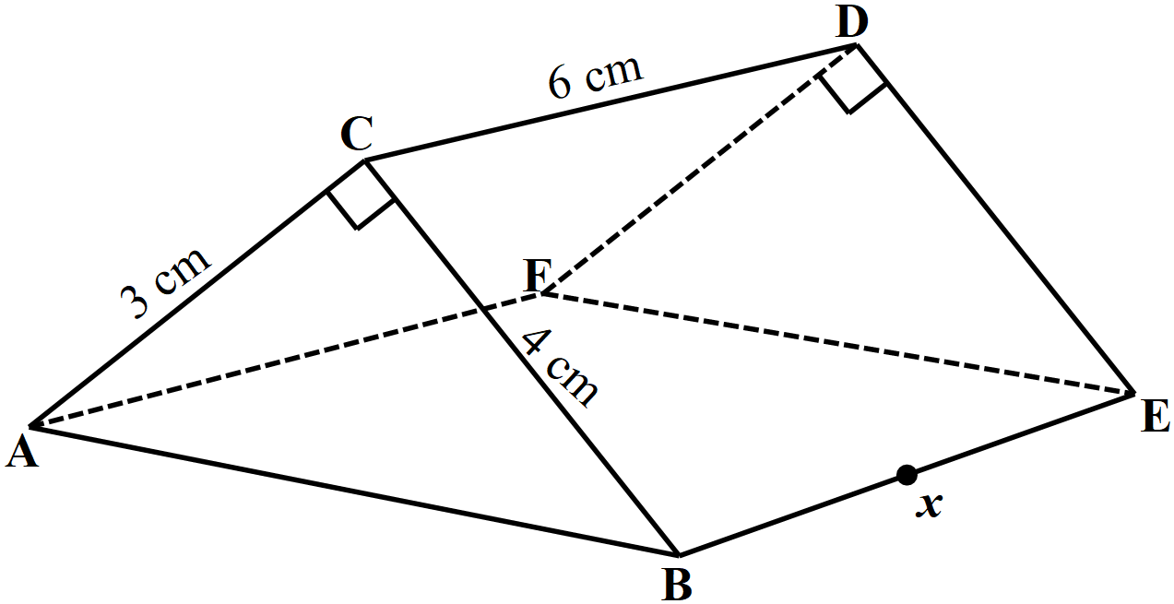

(a) Draw the net of the prism (2 marks)

(b) Using your net, find the distance . (1 mark)

* + - 1. Find the value of in the following equation  (3 marks)
      2. A regular polygon of side has its exterior and interior angle state as  and  respectively. Calculate the area of the polygon correct to 2 decimal places. (4 marks)
      3. Given that  where  is an acute angle. Calculate the value of  leaving your answer in terms of  radians. (3 marks)
      4. (a)Write an expression in terms of ,  and  for the total value of a three digit number having 

as the hundreds digit,  as the tens digit and  as the unit digit. (1 mark)

(b) The number in (a) above is such that the sum of its digits is 13 and the tens digit is 2 less than

the unit digit. When the digits are reversed the number increases by . Find the original

number (3 marks)

* + - 1. The diagram below shows a circle centre . Points ,,, and  are on the circumference of the circle. Given that lines , and  is the diameter of the circle.

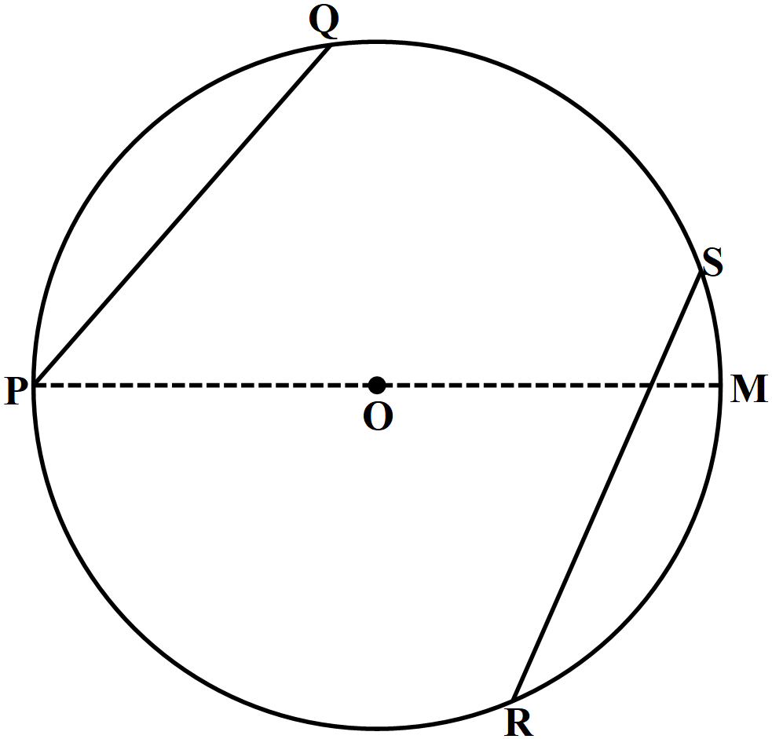

Calculate the size of

(i)  (2 marks)

(ii)  (1 mark)

* + - 1. Use reciprocal, square root and cube tables to evaluate the expression (3 marks)



* + - 1. The figure below shows a sector of a circle centre . The sector subtends an angle of  at the centre and has an area of . The sector is folded to form a cone, calculate the base radius of the cone formed.  (3 marks)

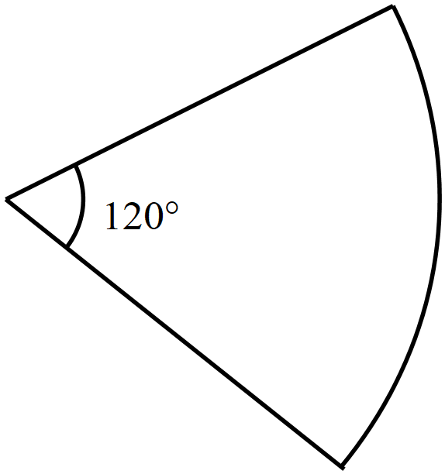

* + - 1. Form all the inequalities that satisfy the given region  (4 marks)

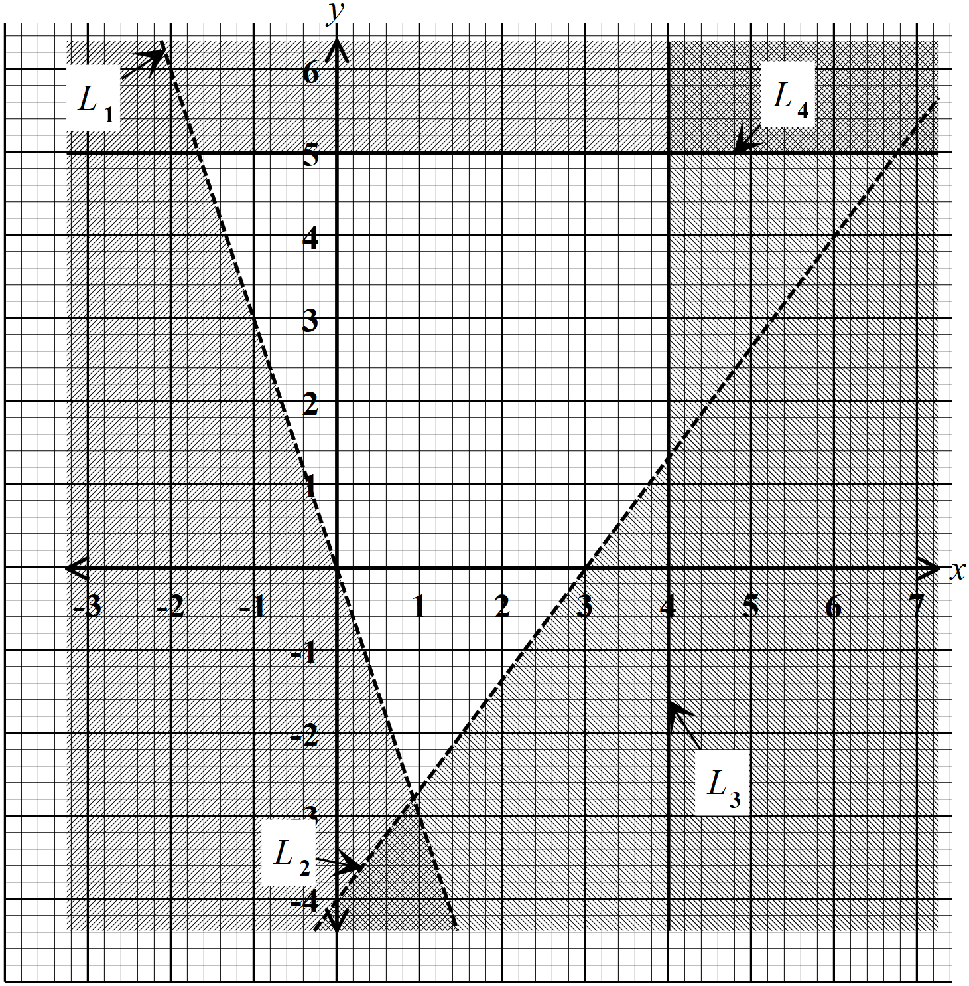

* + - 1. Two ships ,  and , leave port  at the same time, cruises on a bearing of  at a speed  while  cruises due east at speed of .

Using a scale of , draw a diagram to show the positions of the ships after

two hours and hence measure the distance between the two ships. (4 marks)

**SECTION II** (50 marks)

*Answer* ***only five*** *questions in this section in spaces provided*

* + - 1. A point  in mapped onto by a reflection in line .

(a) Find:

(i) the equation of line in the form . (2 marks)

(ii) the equation of line , leaving your answer in the form , where ,  and 

are integers. (3 marks)

(b) A point  is on line  such that . A perpendicular is dropped from point 

to intersect line  at . Calculate the length of correct to 2 decimal places. (3 marks)

(c) A point  is the image of  after a translation . Find the coordinates of the image of

point under the same translation. (2 marks)

* + - 1. 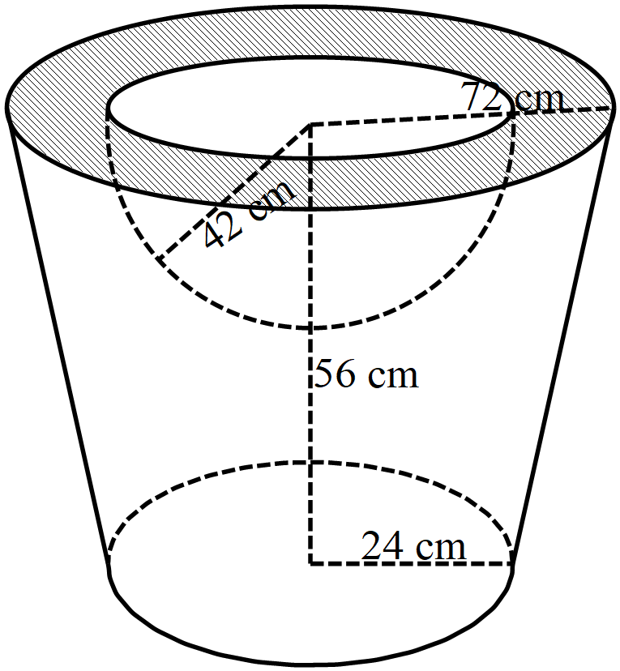The diagram below shows a solid made of brass. It has a hemispherical part of radiusand a conical frustum of height . The top and bottom radius of the conical frustum is  and  respectively. 

(a) Calculate

(i) the volume of the hemispherical part (2 marks)

(ii) the height of the original cone from which the frustum was cut (2 marks)

(iii) the volume of the material used make the solid. (4 marks)

(b) Given that the density of brass is . Calculate the exact mass of the solid in kilograms.

(2 marks)

* + - 1. The following are marks scored by 40 form 4 students in a mathematics test.



(a) Starting with the class and using equal class intervals of 10, make a frequency

distribution. (2 marks)

(b) Use the frequency distribution table in (a) above to Calculate;

(i) the mean mark (3 marks)

(ii) the median mark. (2 marks)

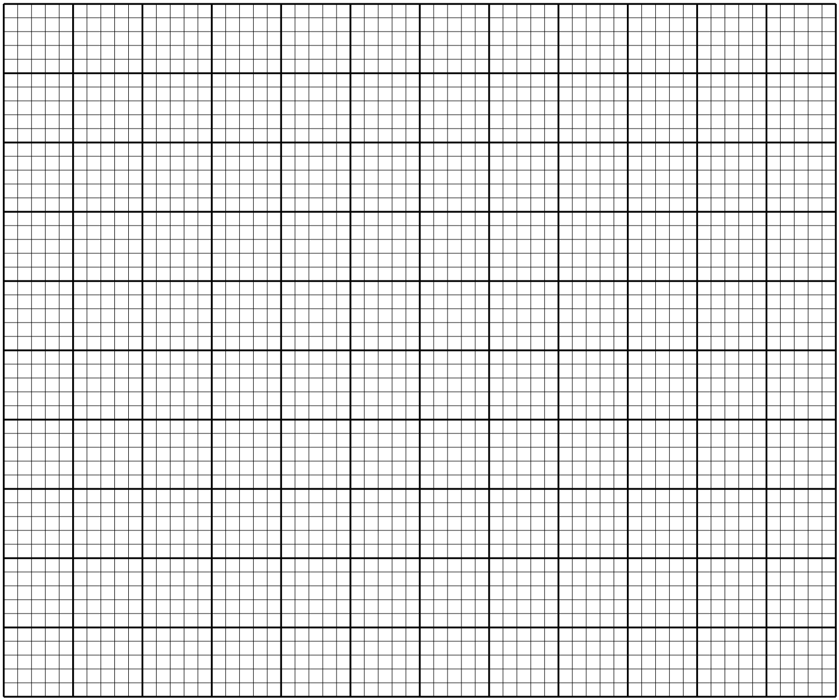(c) Draw a histogram to represent the above data (3 marks)

* + - 1. A bus left Nairobi to Wajir a distance of  and back to Nairobi. Its average speed for the return journey is faster and takes 1 hour 15 minutes less.

(a) If the average speed of the bus from Nairobi to Wajir is , write an expression for:

(i) The time taken by the bus from Nairobi to Wajir. (1 mark)

(ii) The time taken by the bus from Wajir to Nairobi. (1 mark)

(b) Calculate the speed of the bus from Nairobi to Wajir. (5 marks)

(c) A car left Nairobi to Wajir the same day at the same time the bus was starting its return journey

and met the returning bus after travelling for  . Determine the average speed of the car.

(3 marks)

* + - 1. (a)Find the inverse of the matrix  (2 marks)

(b) Akinyi bought  oranges at  and  mangoes at  from supermarket A for

 . The following day, she bought  oranges and  mangoes from supermarket B

spending a total of  more. if the price of an orange was 4 more shillings and a mango

was 5 shilling less from supermarket B.

(i) Form a simplified equation to represent the above information. (2 marks)

(ii) Use matrix method to find the price of an orange and a mango from supermarket A.

(4 marks)

(iii) Use matrix method to calculate the total amount spend to purchase 26 oranges and 64

mangoes from supermarket B. (2 marks)

* + - 1. (a) A triangle  with vertices , and  is mapped onto ,

and  by an enlargement. By calculation, determine the centre and scale factor of

enlargement. (3 marks)

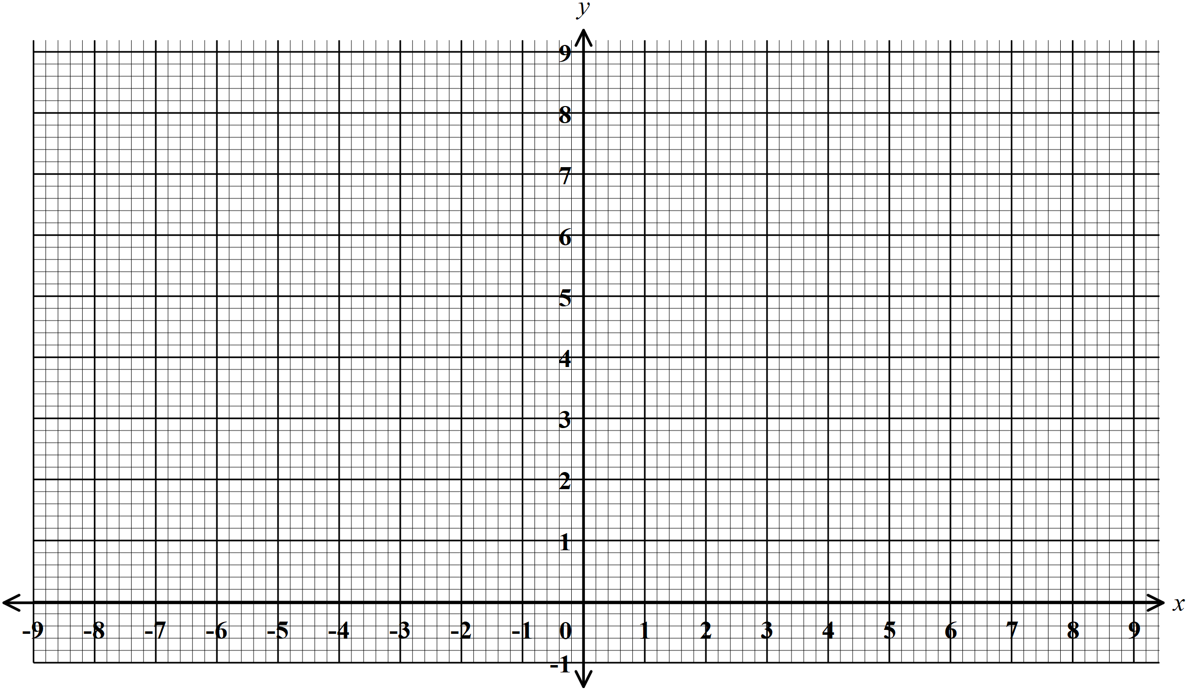(b) Draw  and  on the grid provided. (2 marks)

(c) On the same grid, draw

(i)  the image of  after a reflection in the line  (2 marks)

(ii)  such that it can be mapped onto  by negative quarter turn about

. (2 marks)

(d) State a pair of triangles which are oppositely congruent (1 mark)

* + - 1. Using a ruler and a pair of compasses only:

(a) Construct a triangle  in which ,  and . (3 marks)

(b) Construct the bisector of line  and  to intersect at . (2 marks)

(c) Using  as the centre and  as the radius, draw a circle. Measure its radius. (2 marks)

(d) Calculate the area of circle outside the triangle. (3 marks)

* + - 1. (a) Complete the table below of  for  (2 marks)



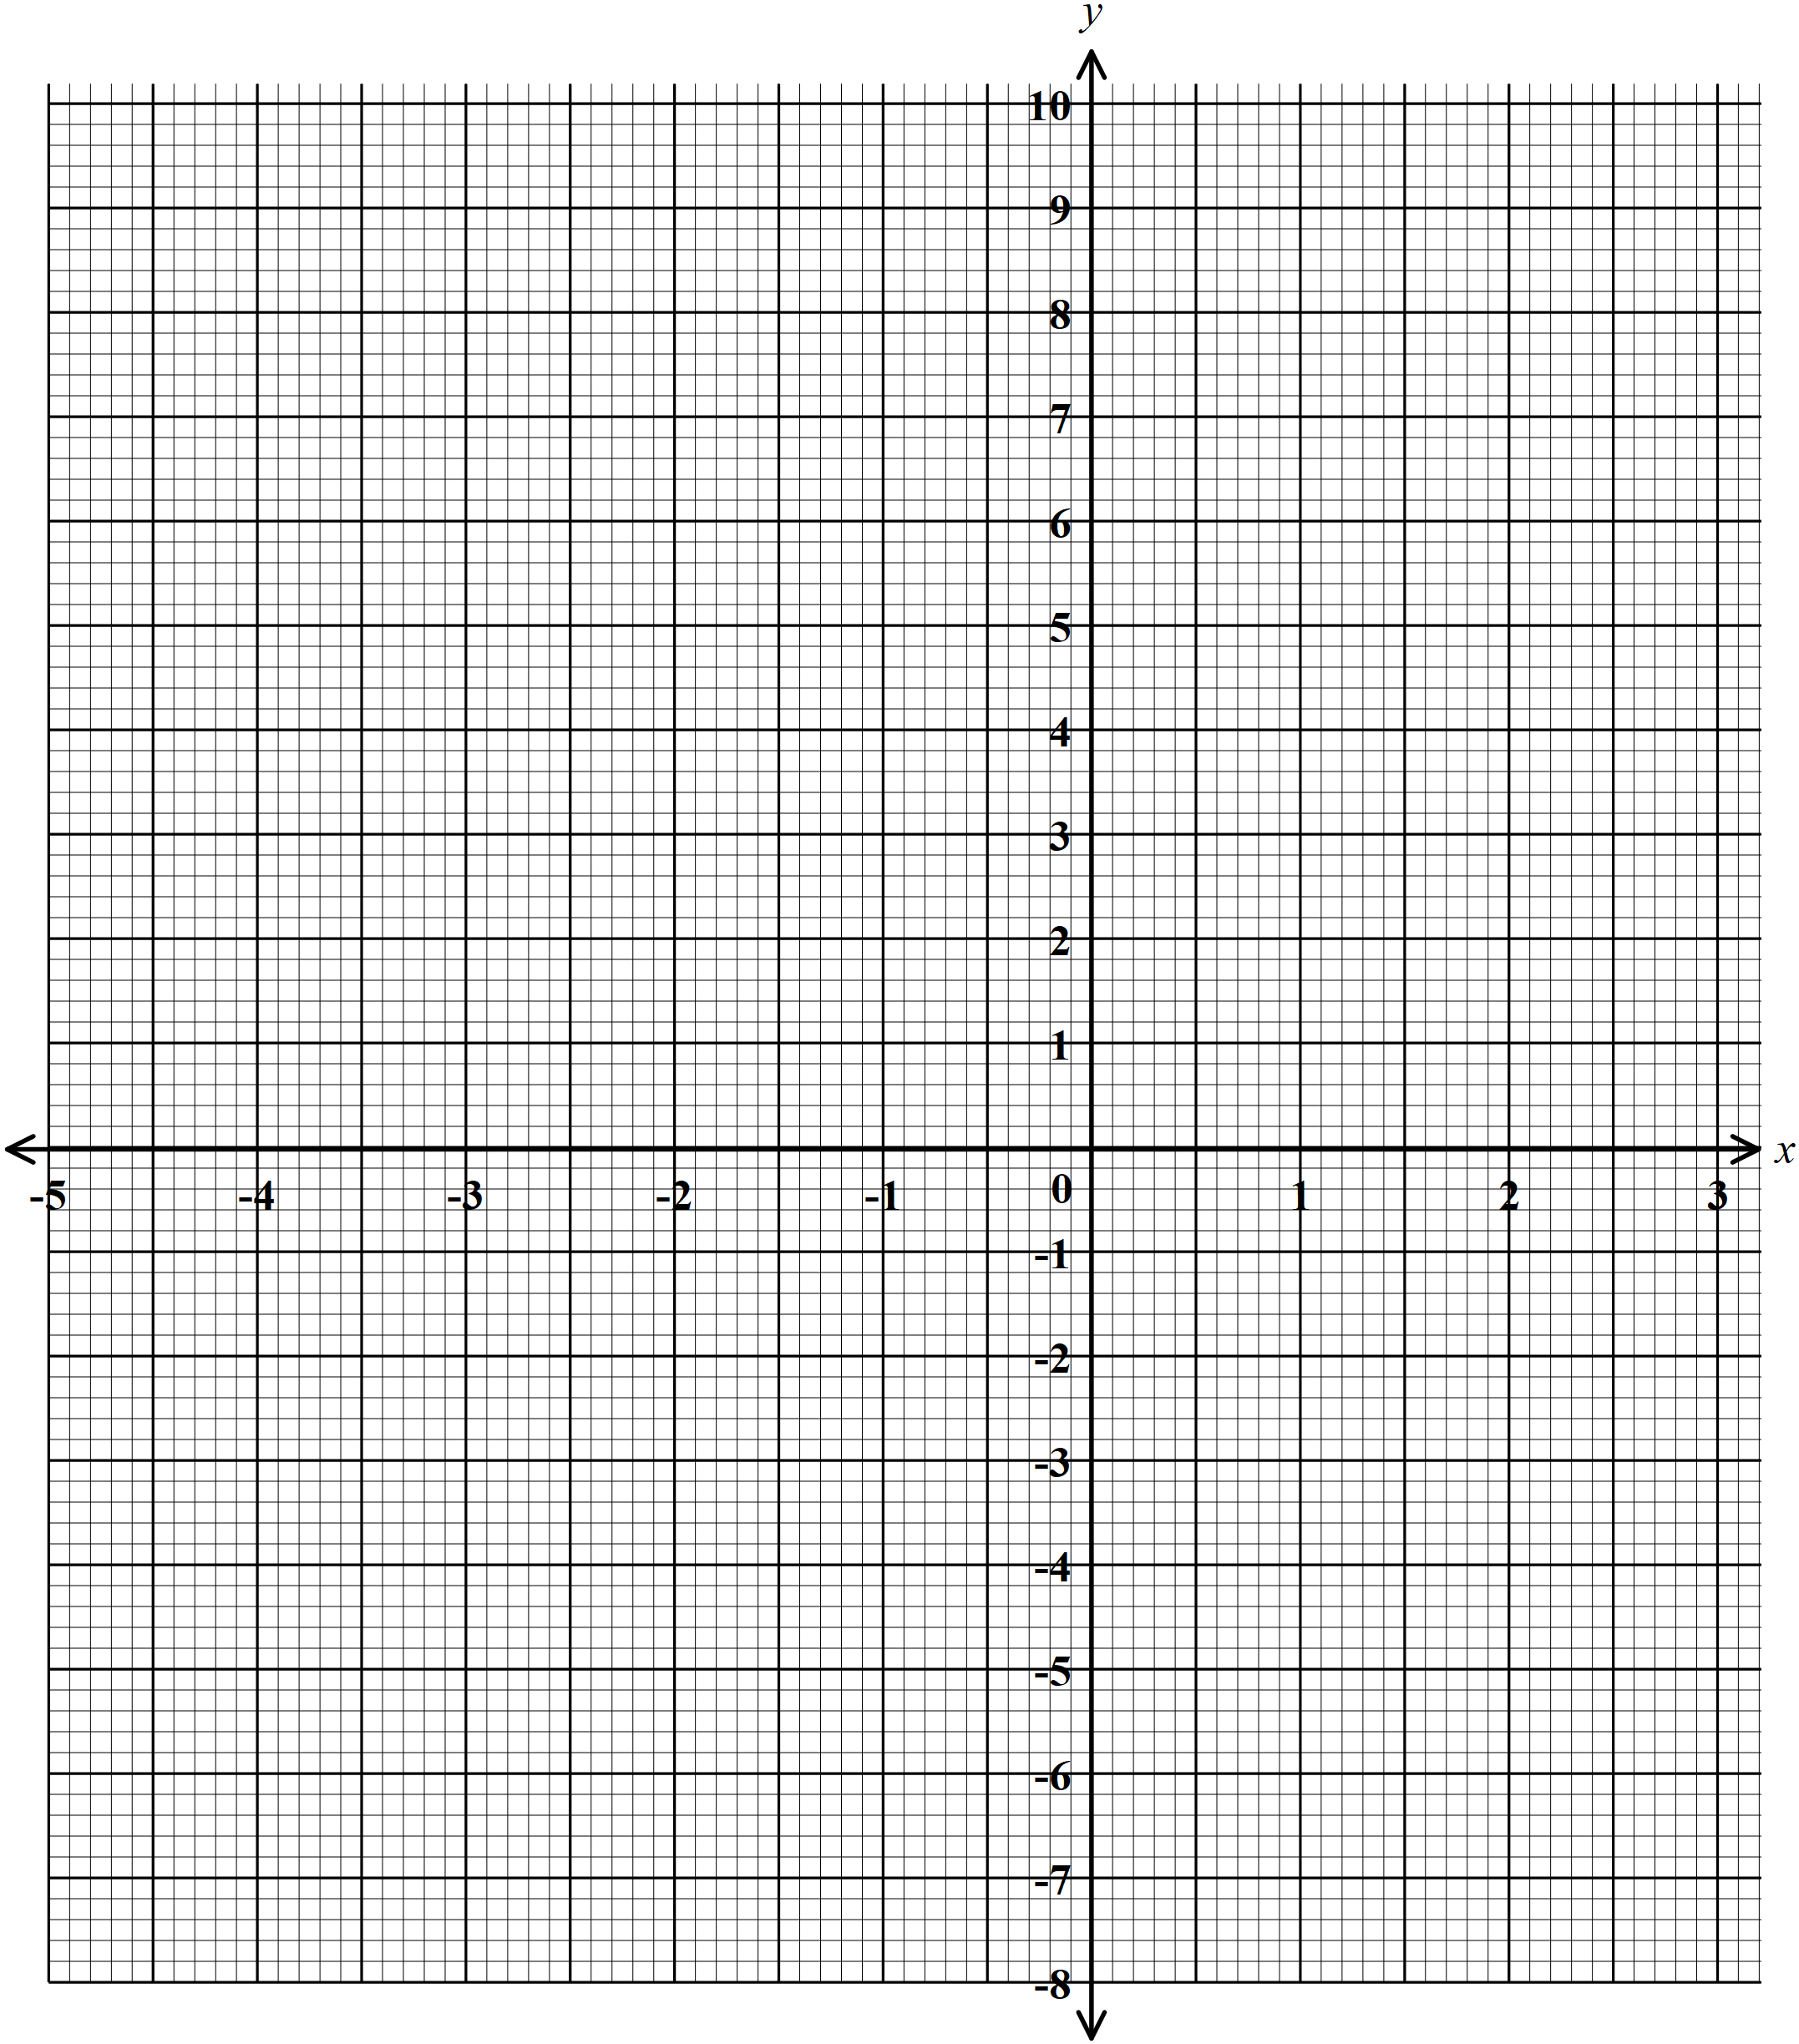 (b) On the grid provided, draw the graph of  (3 marks)

(c) Use your graph to solve

(i)  (1 mark)

(ii)  (2 marks)

(iii)  (2 marks)

